Closing report - Marketflash
Situation – Markus, owner of a small marketing firm is growing and would like to ensure sustainable database management.
Task – Move from spreadsheet-based to database-driven operations. Seek exact stakeholder requirements, validate existing database, and confirm expected results for transforming existing data.
Action(s) –
- Database design stage – Initial Crow’s foot diagram with 1:n relationships assigned as per stakeholder requirement regarding optionality and cardinality. Entities created: Fact table – Campaigns | Dimension tables – rest.
- Establishing entity-relationship stage – Final ERD in Star Schema, assigned relevant datatypes and constraints to all entities. Established relationships with Primary Keys and Foreign Keys.
- Database creation – Sample database in Beekeeper, data population with sample entries, and running a few queries to validate code in Beekeeper.
- Existing database cleanup – Updated data formatting for numbers, location etc. in the existing spreadsheet; date format corrected in Tableau.
- Dashboard mock-up – Based on col. Details available, initial plan was created through a dashboard design mock-up including potential metrics worth analysing.
- Tableau worksheets and dashboard design – Created worksheets followed by dashboard.
- Analysis & insights – Top 3 insights from the dashboard.
Result(s) –
- Crow’s foot
- ERD
- SQL
- Excel
- Mock-up
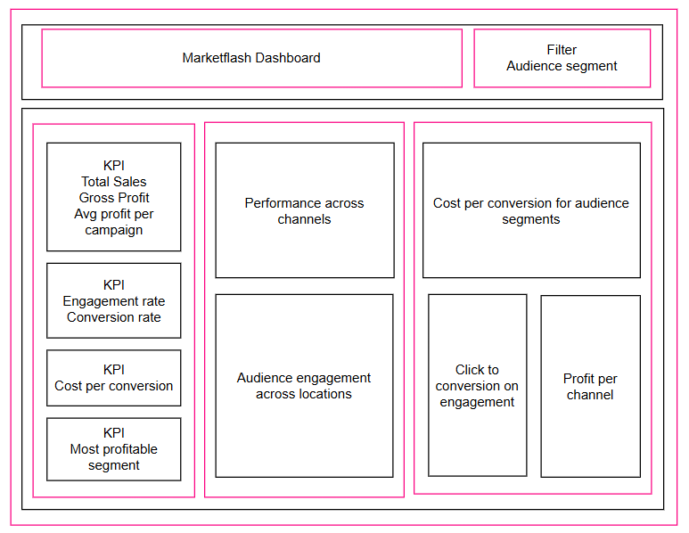

- Visualisation
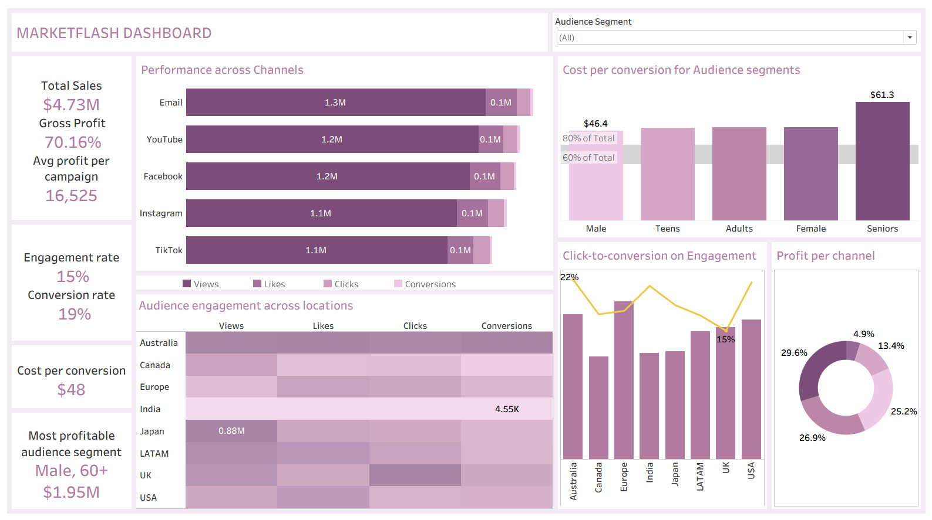

- 3 points worth investigating further:
Dashboard should be read by the stakeholder by using Audience segment as the one-true filter for understanding different metrics for each campaign exclusively targeting different audience segments.
  - High-Value Niche Dominance: The "Male, 60+" segment is most profitable at $1.95M despite being a focused demographic. This suggests a strong product-market fit with this age group and indicates that targeted strategies for older male audiences are delivering better returns relative to broader campaigns.
  - Cost Inefficiency in Senior Segment: While overall conversion rate is strong (20%), Seniors show the highest cost per conversion at $61.3 (vs. $46.4 for other segments). This premium suggests either higher acquisition friction for this group or that conversion pathways may need optimization - worth investigating despite their high profitability.
  - Geographic Concentration Risk: The heatmap shows uneven geographic performance, with India's 53.20k conversions and UK's 7.82M engagement suggesting some regions are outperforming others significantly. This could indicate untapped market potential in underperforming regions or dependency risk if top-performing regions face headwinds.
With the implementation of a live interactive dashboard, stakeholders can get a clearer picture of each campaign performance across the intersection of locations and audience segments.

